##### “Vehicle Detection and Speed Tracking”



***A project report submitted to***

***Rajiv Gandhi Proudyogiki Vishwavidyalaya, Bhopal***

***in partial fulfillment for the award of***

***the degree of***

***Bachelor of Engineering***

***in***

***Computer Science & Engineering***

**DEPARTMENT OF COMPUTER SCIENCE & ENGINEERING**

**SUSHILA DEVI BANSAL COLLEGE OF TECHNOLOGY**

**INDORE- 453331**

**2019-2020**

##### “Vehicle Detection and Speed Tracking”



***A project report submitted to***

***Rajiv Gandhi Proudyogiki Vishwavidyalaya, Bhopal***

***in partial fulfillment for the award of***

***the degree of***

***Bachelor of Engineering***

***in***

***Computer Science & Engineering***

**PROJECT GUIDE SUBMITTED BY**

**Mr. Ankit Upadhyay Animesh Jain (0829CS161020)**

**(Ass. Professor) Brijesh Rathore (0829CS161035)**

**Harsh Verma (0829CS161048)**

**Himanshu Singh Patel (0829CS161049)**

**DEPARTMENT OF COMPUTER SCIENCE & ENGINEERING**

SUSHILA DEVI BANSAL COLLEGE OF TECHNOLOGY

**INDORE- 453331**

**2019-2020**

**ACKNOWLEDGEMENT**

We express deep gratitude for enthusiasm and valuable suggestions that we got from our guide **Mr. Ankit Upadhyay,** Assistant professor, for successful completion of the Software Design Specification of the project. This was not possible without the invaluable guidance of our project guide

We are also thankful to our project coordinator **Mr. Ankit Upadhyay,** Assistant professor, for his technical guidance, encouragement and support.

We are deeply indebted to **Mrs. Reetu Gupta**, Head Department of Computer Science Engineering, for providing us support and resource for successful completion of the work.

We pay deep regards to our Director **Dr. N. Dagdee** who are instrumental in setting standards for the student to achieve.

Finally, we are thankful to all the people who are related to the project directly or indirectly.

**Animesh Jain (0829CS161020)**

**Brijesh Rathore (0829CS161035)**

**Harsh Verma (0829CS161048)**

**Himanshu Singh Patel (0829CS161049)**

SUSHILA DEVI BANSAL COLLEGE OF TECHNOLOGY

**INDORE, 453331**



**CERTIFICATE**

This is to certify that **Animesh Jain (0829CS161020)**, **Brijesh Rathore (0829CS161035)**, **Harsh Verma (0829CS161048)**, **Himanshu Singh Patel (0829CS161049)** have completed their project work, titled **“Vehicle Detection and Speed Tracking”** as per the syllabus and have submitted a satisfactory report on this project as a part of fulfillment towards the degree of **“BACHELOR OF ENGINEERING” (Computer Science & Engineering)**  from **RAJIV GANDHI PROUDYOGIKI VISHWAVIDYALAYA, BHOPAL.**

**HEAD OF THE DEPARTMENT PROJECT GUIDE**

**DIRECTOR**

**SUSHILA DEVI BANSAL COLLEGE OF TECHNOLOGY**

**INDORE, 453331**



**CERTIFICATE**

This is to certify that **Animesh Jain (0829CS161020)**, **Brijesh Rathore (0829CS161035)**, **Harsh Verma (0829CS161048)**, **Himanshu Singh Patel (0829CS161049)** have completed their project work, titled **“Vehicle Detection and Speed Tracking”** as per the syllabus and have submitted a satisfactory report on this project as a part of fulfillment towards the degree of **“BACHELOR OF ENGINEERING” (Computer Science & Engineering)**  from **RAJIV GANDHI PROUDYOGIKI VISHWAVIDYALAYA, BHOPAL.**

**INTERNAL EXAMINER EXTERNAL EXAMINER**

**TABLES OF CONTENTS**

**CHAPTER TITLE PAGE NO.**

**ABSTRACT i**

**LIST OF TABLES ii**

**LIST OF FIGURES iii**

**CHAPTER 1. INTRODUCTION**

1.1 Purpose 1

1.2 Document Conventions 1

1.3 Intended Audience and Reading Suggestions 1

1.4 Scope 2 1.5 Problem Definition 2  
 1.6 Proposed Solution 3

**CHAPTER 2. SYSTEM REQUIREMENT ANALYSIS**

2.1 Overall Description 6 2.1.1 Product Perspective 6

2.1.2 Product Function 7

2.1.3 User Classes And Characteristics 7

2.1.4 Operating Environment 8

2.1.5 Design And Implementation Constraints 8

2.1.6 Assumptions And Dependencies 8

2.2 External Interface Requirement 9  
 2.2.1 User Interfaces 9

2.2.2 Hardware Interfaces 9

2.2.3 Software Interfaces 9

2.2.4 Communications Interfaces 9

2.3 Functional Requirement 10

2.3.1 System Feature 10

2.4 Non Functional Requirement 11

2.4.1 Performance Requirement 11

2.4.2 Safety Requirement 11

2.4.3 Security Requirement 11

2.5 Project Plan 12

2.5.1 Team Members 12

2.5.2 Division Of Work 12

2.5.3 Time Schedule 12

**CHAPTER 3. ANALYSIS**

3.1 Methodology Used 13

3.2 Use Case Diagram 15

3.3 Data Flow Diagram 18

3.4 State Transition Diagram 19

**CHAPTER 4. DESIGN**

4.1 Architectural Design 20

4.1.1 System Architectural Design 20

4.1.2 Description Of Architectural Design 20

4.2 Database Design 21

4.2.1 Normalization 21

4.3 Component Design 22

4.3.1 Flow Chart 22

4.4 Interface Design 23

4.4.1 Screenshots 23

**CHAPTER 5. IMPLEMENTATION**

5.1 Language And Dataset System Used 25

5.2 Features Of Language And Dataset Used 25

5.3 Description Of Third party tools Used 26

**CHAPTER 6. TESTING**

6.1 White Box Testing 27

6.2 Black Box Testing 30

**CHAPTER 7. FUTURE SCOPE AND LIMITATION 31**

**CHAPTER 8. CONCLUSION 32**

**CHAPTER 9. REFERENCE 33**

**ABSTRACT**

Our aim is to build a tracking system which can identify the speed of a vehicle on the road. This information can be used in traffic maintenance, detecting of vehicles with more than specified limit, traffic control, traffic monitoring, traffic flow, security etc. This project will need the concepts of Machine Learning, Video Processing, Image Detection, and some more concept of Computer Vision. It will use data sets for vehicle detection, OpenCV, videos of road, Python-its IDE etc. Finally we will be able to find the speed of vehicle which can be used for traffic maintenance and other things. This will reduce the cost for traffic police and can be used for challan generation and will reduce the accidents on the road.

**LIST OF TABLES**

**Table no. Title Page no.**

2.1.4.1 Operating Environment 8

2.2.2.1 Hardware Interfaces 9

2.2.3.1 Software Interfaces 9

3.2.1 Use Case Specification for Train Model 16

3.2.2 Use Case Specification for Vehicle Detection 16

3.2.3 Use Case Specification for Speed Tracking 17

6.2.1 Test Cases for Black Box Testing 31

**LIST OF FIGURES**

**Figures no. Title Page no.**

1.6.1 Input RGB frame 4

1.6.2 RGB to Gray Scale 4

1.6.3 Detected Vehicle 5

2.1.2.1 Traffic Surveillance System 7

2.3.1.1 Architecture 10

3.1.1 Agile Model 14

3.2.1 Use Case Diagram 15

3.3.1 Level 0 DFD 18

3.3.2 Level 1 DFD 18

3.4.1 State Transition diagram 19

4.1.1.1 Architecture of the Vehicle Detection

& Speed Tracking system 20

4.3.1.1 A general flowchart of vehicle tracking algorithm. 22

4.4.1.1 Output Frame 23

4.4.1.2 Speed of Cars 24

6.1.1 Detection Module Code for White box Testing 27

6.2.2 Flow Chart 30

6.2.3 Directed Graph 30

1. **INTRODUCTION**
   1. **Purpose**

The purpose behind a **project feasibility study** is to know the different variables involved with your business venture and how it will be accepted on the open market along with who will be the target audience. The purpose of this study is to determine the factors that will make the business opportunity that was presented in the business case a success.

* 1. **Document Convention**

**Heading**

• Font size 16

• Font Style Bold

• Font Times New Roman

**Sub Heading**

• Font size 14

• Font style Bold

• Font Times New Roman

**Content**

• Font size 14

• Font Times New Roman

* 1. **Intended Audience and Reading Suggestions**

The intended audience of this document includes system developer who wants to develop similar project for detection purpose like Traffic Surveillance. Since the document is very accurate to development user can read a precise and effective procedure.

* 1. **Scope**

**The Scope of this project is very broad in terms of traffic surveillance.**

The moving vehicle detection, tracking and its speed measurement system is of great significance for present day transport system. Considering limitations of the existing systems such as noise and illumination sensitivity, Traffic controlling, easily detection speed and vehicle details etc.

* 1. **Problem Definition**

Vehicle tracking is the process of locating a moving vehicle using a camera. Capture vehicle in video sequence from surveillance camera is demanding application to improve tracking performance. This technology is increasing the number of applications such as traffic control, traffic monitoring, traffic flow, security etc. The estimated cost using this technology will be very less.

Video and image processing has been used for traffic surveillance, analysis and monitoring of traffic conditions in many cities and urban areas. Various methods for speed estimation are proposed in recent years. All approaches attempt to increase accuracy and decrease cost of hardware implementation. **The aim is to build an automatic system that can accurately localize and track the speed of any vehicles that appear in aerial video frames.**

* 1. **Proposed Solution**
* **Video Data Acquisition :**

In order to examine the performance of the proposed vehicle detection and speed estimation for efficient traffic surveillance the recorded video and some standard vehicle traffic data have been used.

* **Image Pre-Processing :**

To develop efficient vehicle detection and speed estimation scheme, the appropriateness of input data and its quality is of great significance. Here the input RGB video frame has been converted into the frames that has been followed by extraction of various parameters such as number of frames, frame rate, color format, frame size etc.

* **Background Modeling :**

It is the matter of the fact that the core of the Background Subtraction approach is to retrieve the background of the moving video. In traffic surveillance system, while recording video on highway it becomes highly intricate to get the image without any moving vehicle. In order to retrieve such image we have implemented Background Subtraction Model.

* **Vehicle Detection :**

We have detected the vehicle moving in the input video by using some functions provided by OpenCV which gives more accuracy than bounding box generation method.

* **Vehicle Tracking :**

Our proposed vehicle tracking systems have been made on the basis of the feature tracking concept. The features extracted have been tracked over sequential frames retrieved from input traffic video data. Our proposed system represents an object matching scheme that estimates the distance between vehicle features or the features in the previous frame, which has been stored in track graph metrics and instantaneous frame.

* **Speed Estimation Scheme :**

The detected moving vehicles possessing its matching ID have been tracked over frames of the video data. In order to calculate the total number of frames having same object has been estimated using following equation-

Speed = Distance/ (Total Frames*Frame Rate)

* **Predicted Results :**

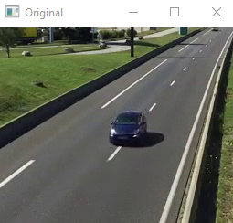

Fig. 1.6.1 Input RGB frame

The above depicted image is an input RGB frame taken from video frames obtained from input video.

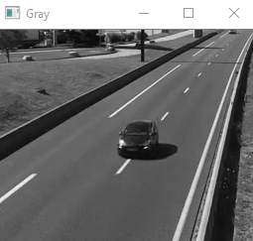

Fig. 1.6.2 RGB to Gray Scale

The input RGB frame is converted to Gray Scale image for performing edge detections and morphological operations.

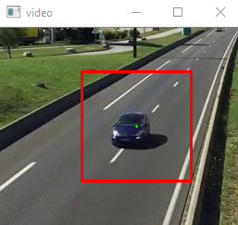

Fig. 1.6.3 Detected Vehicle

The red mark denotes that vehicle is detected.

­

1. **SYSTEM REQUIREMENT ANALYSIS**
   1. **Overall Description**

In systems engineering and software engineering, requirements analysis focuses on the tasks that determine the needs or conditions to meet the new or altered product or project, taking account of the possibly conflicting requirements of the various stakeholders, analyzing, documenting, validating and managing software or system requirements.

Requirements analysis is critical to the success or failure of a systems or software project. The requirements should be documented, actionable, measurable, testable, traceable, related to identified business needs or opportunities, and defined to a level of detail sufficient for system design.

* + 1. **Product Perspective**

One of the significant applications of video-based supervision systems is the Traffic Surveillance. So, for many years of researches have investigated in the vision based intelligent transportation system. The economic and easily availability of hardware have motivated researchers to develop more efficient solution for computer vision based applications. Image Processing based computer vision has become a promising technology for real time supervision, monitoring and control that serves major areas, ranging from civil applications, industries. Especially considering significance of Intelligent Transportation System, the vision based supervision has the significant contribution, as it can facilitate real time monitoring, vehicle tracking and identification. In addition, other parametric identification such as vehicle speeds, Vehicle density, Vehicle Count etc., for efficient traffic monitoring and Control.

However the traditional vehicle systems may be declined and not recognized well due to the vehicles are occluded by other vehicles or by background obstacles such as road signals, trees, weather conditions etc., and the performance of these systems depend on a good traffic image analysis approaches to detect and track the Vehicles.

In this, the traffic image analysis comprises of three parts:-

(1) Motion Vehicle Detection and Segmentation Approaches.

(2) Vehicle Tracking Approaches.

* + 1. **Product Function**
  + **Vehicle Detection:**

We detected the vehicle moving in the input video by using region props function which is an inbuilt function in mat lab and gives more accuracy than bounding box generation method.

* + **Vehicle Tracking:**

In this paper the proposed vehicle tracking system has been made on the basis of the feature tracking concept. The features extracted have been tracked over sequential frames retrieved from input traffic video data. Our proposed system represents an object matching scheme that estimates the distance between vehicle features or the features in the previous frame, which has been stored in track graph metrics and instantaneous frame.

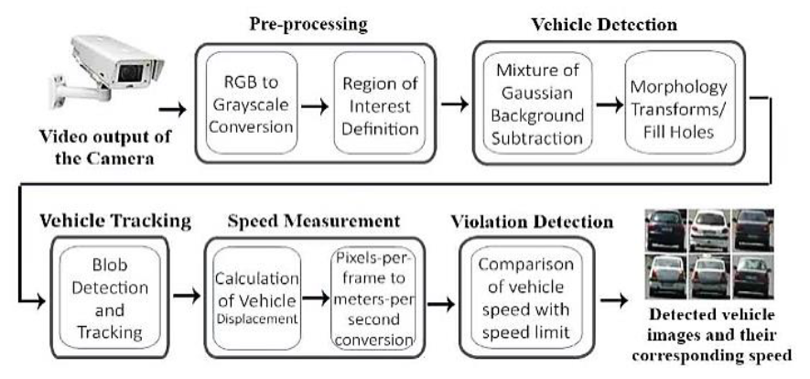

Fig. 2.1.2.1 Traffic Surveillance System

* + 1. **User Classes And Characteristics**

This is subsystem of a large model which can be used by any project or mainly for the surveillance purpose. This information can be used in traffic maintenance, detecting of vehicles with more than specified limit, traffic control, traffic monitoring, traffic flow, security etc.

* + 1. **Operating Environment**

|  |  |  |
| --- | --- | --- |
| **S.NO.** | **NAME** | **HARDWARE** |
| 1. | Processor | Intel core i5 (64 bit) |
| 2. | RAM | 4 GB |
| 3. | Processor Speed | 2.30 GHz |

Table 2.1.4.1 Operating Environment

* + 1. **Design And Implementation Constraints**
* Language of choice: PYTHON.
* Libraries: OpenCV, Time.
* Platform for deployment: PYCHARM.
* Dataset:<https://medusa.fit.vutbr.cz/traffic/research-topics/detection-of-vehicles-and-datasets>
  + 1. **Assumptions And Dependencies**

We are limited to the dataset which we have taken in terms of detections. The threshold values will change according to the videos. The speed of the vehicle should not exceed beyond certain limits. There should be proper lighting for detection.

**2.2 External interface Requirements**

**2.2.1 User Interfaces**

Our System will not contain any user interface, since it is a subsystem which can be used by any other system like traffic surveillance. But user can use it through command line interface or through any python IDE.

**2.2.2 Hardware Interfaces**

|  |  |  |
| --- | --- | --- |
| **S.NO.** | **NAME** | **HARDWARE** |
| 1. | Processor | Intel core i5 (64 bit) |
| 2. | RAM | 4 GB |
| 3. | Processor Speed | 2.30 GHz |

Table 2.2.2.1 Hardware Interfaces

2.2.3 Software Interfaces

|  |  |  |
| --- | --- | --- |
| **S. No** | **NAME** | **SOFTWARE** |
| **1** | Platform | Windows 10 |
| **2** | IDE | PyCharm |
| **3** | Libraries | OpenCV  Time |

Table 2.2.3.1 Software Interfaces

2.2.4 Communications Interfaces

* Windows

**2.3 Functional Requirement**

**2.3.1 System Feature**

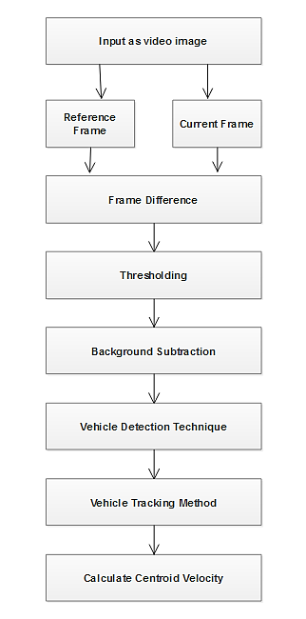

Fig. 2.3.1.1 Architecture

1. **Image processing**

To get better results, vehicle detection process should be performed in the grayscale image domain. Hence a RGB to grayscale conversion is performed on each video frame. To achieve an appropriate threshold level and make results more suitable than the input image, each frame should be brought in contrast to background.

1. **Background Subtraction**

Using provided threshold, the static parts of sequential video frames should be cleaned. The main challenge here is that the performance of image analysis algorithms suffers from darkness, glare, long shadows or bad illumination at night, which may cause strong noises. Therefore, the grayscale image might be unspecified in these situations and make the detection task a bit more complex. Edges essentially separate two various regions which are static region (the roadway) and dynamic region (moving vehicles). The static background is then deleted to locate moving objects in each frame. The result zone leaves only vehicles and some details as moving objects in sequential images which are changing frame to frame.

1. **Vehicle Detection**

As an observation (detection) zone, a region should be defined to display moving vehicle’s edges in a bounding box at the time that the vehicle enters it. This zone is in the middle of the screen and covers 1/3 of its height and 3/5 of its width (considering minimum and maximum available size of detectable passing vehicles in pixels).

1. **Vehicle Tacking**

The output of detection step i.e. vehicle’s blob inside the ROI- should be tracked in sequential frames to detect motion. Tracking process can be performed using various techniques. In the proposed method, if the vehicle has just entered the ROI, means it has not been tracked yet, it should be labeled by a Vehicle ID.

**2.4 Non Functional Requiremet**

* + 1. **Performance Requirements**

It will change whole system of traffic control and surveillance drastically because of video processing and less influence of human beings.

* + 1. **Safety Requirements**

The accident on the road will reduce by using this system.

* + 1. **Security Requirement**

There should no dust on the camera’s for detection and the atmospheric condition can change the resultant results.

2.5 Project Plan

2.5.1 Team Members

Name: Harsh Verma

Email: [harshverm776@gmail.com](mailto:harshverm776@gmail.com)

Name: Brijesh Rathore

Email: [rathorebrijesh55@gmail.com](mailto:rathorebrijesh55@gmail.com)

Name: Himanshu Singh Patel

Email: [himanshu.patel.sdbc@gmail.com](mailto:himanshu.patel.sdbc@gmail.com)

Name: Animesh Jain

Email: [animesh3jain@gmail.com](mailto:animesh3jain@gmail.com)

**2.5.2 Division of Work**

***“A team is on success gate if every individual is loyal to his/her***

***responsibility.”***

***Harsh Verma***: Requirement Gathering, Documentation,

Programming.

***Brijesh Rathore****:* Requirement Gathering, UML Diagrams,

PPT, Programming.

***Himanshu Singh Patel*:** PPT, Programming, UML Diagrams.

***Animesh Jain*:** Documentation, PPT.

**Time Schedule**

**1**. **Requirement Analysis** : Approximately 15 days

**2**. **Design** : Approximately 10 days

**3**. **Coding** : Approximately 30 days

**4**. **Testing** : Approximately 10 days

**3 ANALYSIS**

**3.1 Methodology Used**

The programming language used for the development of the project is PYTHON and the software model used is the agile model.

***Agile Model***

Agile SDLC model is a combination of iterative and incremental process models with focus on process adaptability and customer satisfaction by rapid delivery of working software product. Agile Methods break the product into small incremental builds. These builds are provided in iterations. Each iteration typically lasts from about one to three weeks. Every iteration involves cross functional teams working simultaneously on various areas like −

* Planning
* Requirements Analysis
* Design
* Coding
* Unit Testing and
* Acceptance Testing.

***Advantages of Agile model:***

* Is a very realistic approach to software development.
* Promotes teamwork and cross training.
* Functionality can be developed rapidly and demonstrated.
* Resource requirements are minimum.
* Suitable for fixed or changing requirements
* Delivers early partial working solutions.
* Good model for environments that change steadily.
* Minimal rules, documentation easily employed.
* Enables concurrent development and delivery within an overall planned context.
* Little or no planning required.

***Disadvantage of Agile model:***

* Not suitable for handling complex dependencies.
* More risk of sustainability, maintainability and extensibility.
* An overall plan, an agile leader and agile PM practice is a must without which it will not work.
* Strict delivery management dictates the scope, functionality to be delivered, and adjustments to meet the deadlines.
* Depends heavily on customer interaction, so if customer is not clear, team can be driven in the wrong direction.
* There is a very high individual dependency, since there is minimum documentation generated.
* Transfer of technology to new team members may be quite challenging due to lack of documentation.

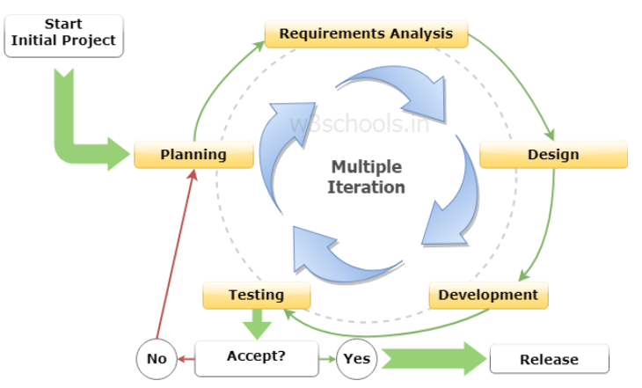

Fig. 3.1.1 Agile Model

**3.2 Usecase Diagram**

1. **Usecase Diagram**

A use case diagram at its simplest is a representation of user’s interaction with the system that shows the relationship between the user and the different use case in which the users is involved. A use case diagram can identify the different types of user of a system and the different use cases.

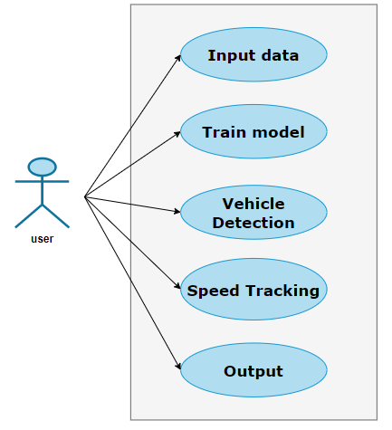

Fig. 3.2.1 Use Case Diagram

1. **Use Case Specification**

|  |  |
| --- | --- |
| Name of the use case | Train Model |
| Actor | User |
| Precondition | Frame should available |
| Primary flow of events | It should preform vehicle detection. |
| Alternate flow of events | If frame is not available then the program while terminate. |
| Post condition | Vehicle detection will take place. |
| Use case termination | Cancel |

Table 3.2.1 Use Case Specification for Train Model

|  |  |
| --- | --- |
| Name of the use case | Vehicle Detection |
| Actor | User |
| Precondition | Train Model should work perfectly. |
| Primary flow of events | It should preform speed tracking. |
| Alternate flow of events | Vechile detection can’t be performed. |
| Post condition | Speed Tracking will take place. |
| Use case termination | Cancel |

Table 3.2.2 Use Case Specification for Train Model

|  |  |
| --- | --- |
| Name of the use case | Speed Tracking |
| Actor | User |
| Precondition | Vehicle detection should work perfectly. |
| Primary flow of events | It will show video. |
| Alternate flow of events | Speed tracking can’t be performed. |
| Post condition | Show Video. |
| Use case termination | Cancel |

Table 3.2.3 Use Case Specification for Speed Tracking

**3.3 Data Flow Diagram**

Also known as DFD, Data flow diagrams are used to graphically represent the flow of data in a business information system. DFD describes the processes that are involved in a system to transfer data from the input to the file storage and reports generation.

Data flow diagrams can be divided into logical and physical. The logical data flow diagram describes flow of data through a system to perform certain functionality of a business. The physical data flow diagram describes the implementation of the logical data flow.

* 1. **LEVEL 0 DFD**

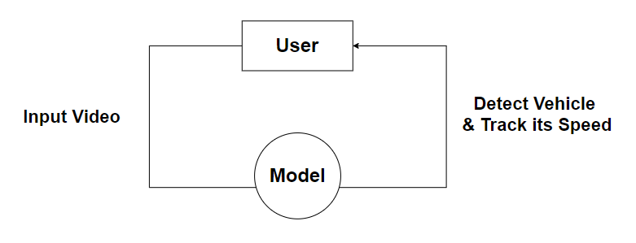

Fig. 3.3.1 Level 0 DFD

* 1. **LEVEL 1 DFD**

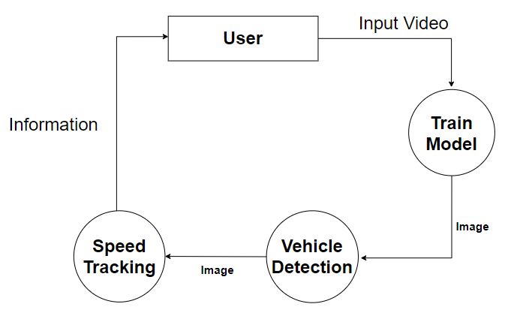

Fig. 3.3.2 Level 1 DFD

**3.4 State Transition Diagram**

A state diagram is used to represent the condition of the system or part of the system at finite instances of time. It’s a behavioral diagram and it represents the behavior using finite state transitions. State diagrams are also referred to as State machines and State-chart Diagrams. These terms are often used interchangeably. So simply, a state diagram is used to model the dynamic behavior of a class in response to time and changing external stimuli. We can say that each and every class has a state but we don’t model every class using State diagrams. We prefer to model the states with three or more states.

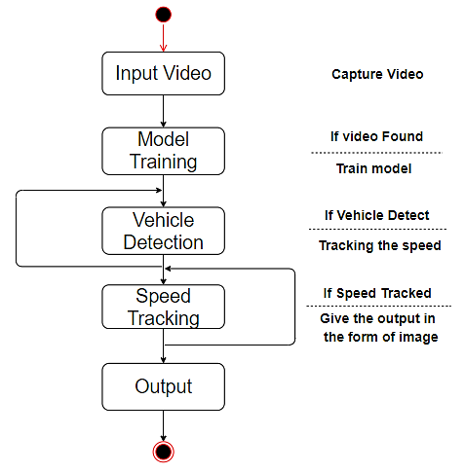

Fig. 3.4.1 State Transition diagram

1. **DESIGN**
   1. **Architectural Design**

**4.1.1 System Architectural Design**

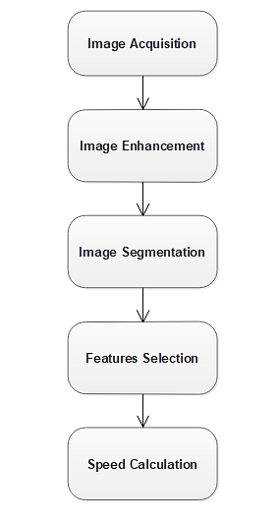

Fig: 4.1.1.1 Architecture of the Vehicle Detection & Speed Tracking

system

**4.1.2 Description of Architectural Diagram**

* **Image Acquisition:**

In image processing, it is defined as the action of retrieving an image from some source, usually a hardware-based source for processing. It is the first step in the workflow sequence because, without an image, no processing is possible. The image that is acquired is completely unprocessed.

* **Image Enhancement :**

Image enhancement is the process of adjusting digital images so that the results are more suitable for display or further image analysis. For example, we can remove noise, sharpen, or brighten an image, making it easier to identify key features.

* **Image Segmentation :**

Segmentation is the technique of dividing or partitioning an image into parts, called segments. It is mostly useful for applications like image compression or object recognition, because for these types of applications, it is inefficient to process the whole image.

* **Feature Selection :**

Feature Selection is the process where we automatically or manually select those features which contribute most to your prediction variable or output in which we are interested in. Having irrelevant features in our data can decrease the accuracy of the models and make our model learn based on irrelevant features.

* **Speed Calculation :**

The detected moving vehicles possessing its matching ID have been tracked over frames of the video data. In order to calculate the total number of frames having same object has been estimated using following equation-

Speed = Distance/ (Total Frames*Frame Rate)

* 1. **Database Design**
     1. **Normalization**

Since we are using videos and there is no need for storing data we do not have database So there is no need of normalization.

* 1. **Component Diagram**

**4.3.1 Flow chart**

A flow chart is a type of a diagram that represents an algorithm, workflow or process, showing the steps as boxes of various kinds, and there order by connecting them with arrows. This diagrammatic representation illustrates a solution model to a given problem. Flow charts are used in analyzing, designing, documenting or managing a process program in a various field.



Fig: 4.3.1.1 A general flowchart of vehicle tracking algorithm.

* 1. **Interface Design**

User interface is the front-end application view to which user interacts in order to use the software. User can manipulate and control the software as well as hardware by means of user interface.

UI can be graphical, text based, audio-video based, depending upon the under lying hardware and software combination. UI can be hardware or software or a combination of both.

* + 1. **Screen Shots**

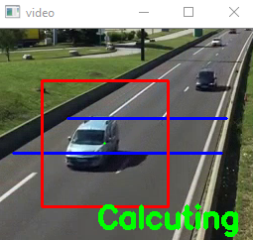

Fig: 4.4.1.1 Output Frame

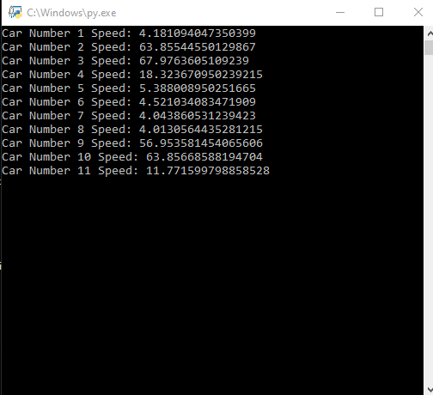

Fig: 4.4.1.2 Speed of Cars

1. **IMPLEMENTATION**
   1. **Language and Dataset Used For The Implementation**

***Python:***

Python is an interpreted, high-level, general-purpose programming language. Created by Guido van Rossum and first released in 1991, Python's design philosophy emphasizes code readability through use of significant whitespace. Its language constructs and object-oriented approach aim to help programmers write clear, logical code for small and large-scale projects.

***Dataset:***

We have use dataset published by SOCHOR Jakub et al. Comprehensive Data Set for Automatic Single Camera Visual Speed Measurement, IEEE T-ITS.

* 1. **Feature Of language & dataset used for the project**

***Feature of Python:***

* + - Easy to Learn and Use.
    - Expressive Language.
    - Interpreted Language.
    - Cross-platform Language.
    - Free and Open Source.
    - Object-Oriented Language.
    - Extensible.
    - Large Standard Library.
    - GUI Programming Support.
    - Integrated.

***Feature of Dataset:***

Our dataset contain good quality videos in which each road have its three angles- center, right and left.

* + - Frame W-H : 1920 x 1080
    - Data rate : 8001 kbps
    - Bit rate : 8001 kbps
    - Frame rate : 50 frames/second
  1. **Description Of Third Party tools used**

***PyCharm:***

PyCharm is an integrated development environment (IDE) used in computer programming, specifically for the Python language. It is developed by the Czech company JetBrains. It provides code analysis, a graphical debugger, an integrated unit tester, integration with version control systems (VCSes), and supports web development with Django as well as Data Science with Anaconda.

***OpenCV:***

OpenCV (Open source computer vision) is a library of programming functions mainly aimed at real-time computer vision. Originally developed by Intel, it was later supported by Willow Garage then Itseez (which was later acquired by Intel). The library is cross-platform and free for use under the open-source BSD license. OpenCV supports the deep learning frameworks TensorFlow, Torch/ PyTorch and Caffe.

***Time:***

The Python time module provides many ways of representing time in code, such as objects, numbers, and strings. It also provides functionality other than representing time, like waiting during code execution and measuring the efficiency of your code.

***Any Video Converter Ultimate:***

Any Video Converter Ultimate can help us to watch DVD movies and listen to music from CDs anywhere by converting DVD & CD and Blu-ray movies to popular formats like MP4, M4V, AVI, WMV, MOV, WMA, MP3, etc. Also, it can burn media files to blank DVD disc and play it on any DVD player. Any Video Converter Ultimate allows us to backup our DVD by burning content from one DVD to another unused DVD.

**6 TESTING**

* 1. **White Box Testing**

White box testing is defined as the testing of software solution’s internal structure, design, and coding. In this type of testing, the code is visible to the tester. It focuses primarily on verifying the flow of inputs and outputs through the application, improving design and usability, strengthening security. White box testing is also called Clear testing, Open Box Testing, Structural testing, Transparent Testing, Code-Based Testing and Glass Box Testing.

**Detection Module:**

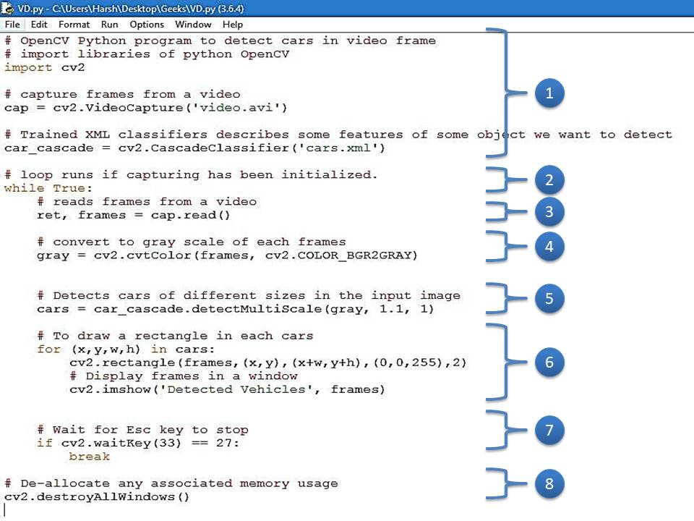

Fig: 6.1.1 Detection Module Code for White box Testing

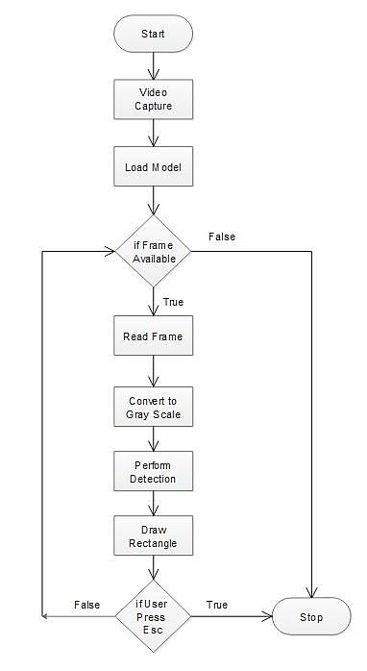 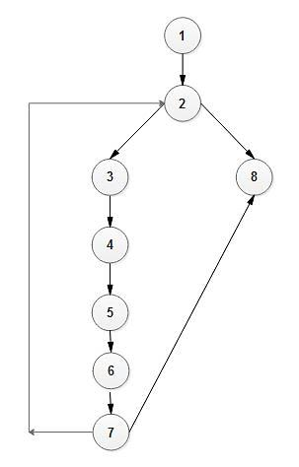

Fig: 6.2.2 Flow Chart Fig: 6.2.3 Directed Graph

**Cyclomatic Complexity:**

* + - 1. V(G) = P + 1, where P is the number of predicate nodes in the flow graph.

V(G) = 2 + 1 = 3

* + - 1. V(G) = E – N + 2, where E is the number of edges and N is the total number of nodes.

V(G) = 9 - 8 + 2 = 3

* + - 1. V(G) = B + 1, where B is Number of non-overlapping regions in the graph.

V(G) = 2 + 1 = 3.

**Test Cases**

* + **Test Case Name:** When frame is available in data set.

**Expected Outcome:** It should go in a loop for reading a frame & performing detection.

**Actual Outcome:** It is going in a loop for reading a frame & performing detection.

**Path:** 1 🡺 2 🡺 3 🡺 4 🡺 5 🡺 6 🡺 7 🡺 2 …

**Result:** Pass.

* + **Test Case Name:** When frame is available in data set & Esc key is pressed after some time.

**Expected Outcome:** It should go in a loop for reading a frame & performing detection & stop after sometime.

**Actual Outcome:** It is going in a loop for reading a frame & performing detection & stop after sometime.

**Path:** 1 🡺 2 🡺 3 🡺 4 🡺 5 🡺 6 🡺 7 🡺 8

**Result:** Pass.

* + **Test Case Name:** When frame is not available in data set.

**Expected Outcome:** It should break the loop and show the output.

**Actual Outcome:** It break the loop and show the output.

**Path:** 1 🡺 2 🡺 8

**Result:** Pass.

* 1. **Black box Testing**

Black box testing is also known as Behavioral Testing, is software testing method in which the internal structure/ design/ implementation of the item being tested is not known to the tester. These tests can be functional or non-functional, through usually functional.

This method is named so because the software program, in the eyes of the tester, is like a black box; inside which one cannot See.

|  |  |  |  |  |  |
| --- | --- | --- | --- | --- | --- |
| TEST CASE | TEST CASE DESCRIPTION | TEST DATA | EXPECTED RESULT | ACTUAL RESULT | PASS/FAIL |
| **1.** | **Video containing vehicles** | **Video** | **Detect Successfully** | **Detect Successfully** | **Pass** |
| **2.** | **Video not containing vehicles** | **Video** | **Not Detected** | **Not Detected** | **Pass** |
| **3.** | **Video Quality** | **Video**  **(More Blur)** | **Not Detected** | **Not Detected** | **Pass** |

Table 6.2.1 Test Cases for Black Box Testing

1. **FUTURE SCOPE AND LIMITATION**

**Scope:-**

**The Scope of this project is very important to traffic surveillance and control.**

Few points are:-

* This can be used for auto generation of challan using more camera and accuracy.
* The stolen vehicle can be detected by comparing with the registered entry of stolen vehicles.
* Can be used as traffic counters to count the number of vehicles plying on a highway.
* The Number plate of vehicle which has crossed over speed limit can be sent to mobile of traffic police in the area using Android application.

**Limitation:-**

* It will work perfect in proper lighting only.
* It is having less efficiency and accuracy.
* Accuracy can be increased using Neural Networks. Advanced image processing algorithms and libraries could be used so that the system can be used efficiently even during unfavorable lighting conditions and during the night time as well.

1. **CONCLUSION**

**We are able to recognize speed of vehicles from the recorded video frames till a limited extent.** The moving vehicle detection, tracking and its speed measurement system is of great significance for present day transport system. Vehicle tracking system makes better fleet management and which in turn brings large profits. Better scheduling or route planning can enable us to handle larger jobs loads within a particular time. Vehicle tracking both in case of personal as well as business purpose improves safety and security, communication medium, performance monitoring and increases productivity. So in the coming year, it is going to play a major role in our day-to-day living.

1. **REFERENCE**

**Reports:**

* **“Motion-based Vehicle Speed Measurement for Intelligent Transportation Systems”** by Ali Tourani, Department of Computer Engineering, University of Guilan, Rasht, Iran.
* **“Vehicle Tracking and Speed Estimation from Traffic Videos”** by Shuai Hua, Manika Kapoor, David C. Anastasiu, Department of Computer Engineering, San Jose State University, San Jose, CA.
* **“Vehicle Detection, Tracking and Speed Measurement for Traffic Regulation”** by Pulli Harsha Samhitha, Allu Naga Jyothi, Ramana Vesapogu, Manasa Mannem, S. Sri Harsha, V .R .Siddhartha Engineering College, JNTUK, Vijayawada, Associate Professor, Dept of Information Technology, V. R .Siddhartha Engineering College, Vijayawada, Andhra Pradesh, India

**Website:**

* UML Diagrams- <https://app.diagrams.net/>